

**CAPSTONE PROJECT REPORT**

**Report 2 – Project Management Plan**

– Hanoi, August 2019 –

**Table of Contents**

I. Project Report 3

1. Status Report 3

2. Team Involvements 3

3. Issues/Suggestions 3

II. Project Management Plan 4

1. Overview 4

1.1 WBS & Estimation 4

1.2 Project Objectives 4

1.3 Project Risks 4

2. Management Approach 5

2.1 Project Process 5

2.2 Quality Management 5

2.3 Training Plan 5

3. Master Schedule 5

4. Project Organization 6

4.1 Team & Structures 6

4.2 Roles & Responsibilities 6

5. Project Communication 6

5.1 Communication Plan 6

5.2 External Interface 7

6. Configuration Management 7

6.1 Tools & Infrastructures 7

6.2 Document Management 8

6.3 Source Code Management 8

# I. Project Report

## 1. Status Report

|  |  |  |  |
| --- | --- | --- | --- |
| **#** | **Work Item** | **Status** | **Notes (Work Item in Details)** |
| 1 |  | Pending |  |
| 2 |  | In Progress |  |
| 3 |  | Completed |  |

## 2. Team Involvements

|  |  |  |  |
| --- | --- | --- | --- |
| **#** | **Task** | **Member** | **Notes (Task Details, etc.)** |
| 1 |  | KienNT |  |
| 2 |  | TuanTV |  |
| 3 |  | AnhLM |  |

## 3. Issues/Suggestions

|  |  |  |  |
| --- | --- | --- | --- |
| **#** | **Issue** | **Status** | **Notes (Solution, Suggestion, etc.)** |
| 1 |  | Pending |  |
| 2 |  | In Progress |  |
| 3 |  | Completed |  |

# II. Project Management Plan

## 1. Overview

### 1.1 WBS & Estimation

|  |  |  |  |
| --- | --- | --- | --- |
| **#** | **WBS Item** | **Complexity** | **Est. Effort** |
| ***1*** | ***Initiating*** |  |  |
| 1.1 | Collect requirement | Simple | 4 |
| ***2*** | ***Planning*** |  |  |
| 2.1 | Create project plan document |  | 2 |
| ***3*** | ***Executing*** |  |  |
| 3.1 | Analysis |  |  |
| 3.1.1 | Software requirements specification(SRS) |  | 12 |
| 3.2 | Design |  |  |
| 3.2.1 | Software design document |  | 12 |
| 3.2.2 | User Interface |  | 5 |
| 3.3 | Code |  |  |
| 3.3.1 | Web admin |  | 7 |
| 3.3.2 | Mobile app |  | 7 |
| 3.4 | Testing |  |  |
| 3.4.1 | Reviewing |  |  |
| 3.4.2 | Unit Test |  |  |
| 3.4.3 | Integration Test |  |  |
| 3.4.4 | System Test |  |  |
|  |  |  |  |
|  |  |  |  |
| ***Total Estimated Effort (man-days)*** | | | ***21*** |

### 1.2 Project Objectives

|  |  |  |  |  |
| --- | --- | --- | --- | --- |
| **#** | **Quality Stage** | **No. of Defects** | **% of Defect** | **Notes** |
| 1 | Reviewing |  |  |  |
| 2 | Unit Test |  |  |  |
| 3 | Integration Test |  |  |  |
| 4 | System Test |  |  |  |
| ***Total*** | | ***Xxx*** | ***100%*** |  |

### 1.3 Project Risks

|  |  |  |  |  |
| --- | --- | --- | --- | --- |
| **#** | **Risk Description** | **Impact** | **Possibility** | **Response Plans** |
| 1 | Time Risks |  |  |  |
| 2 | Technology Risks |  |  |  |

## 2. Management Approach

Agile project management aims to mold an organization to fluidly respond to changes or developments in projects as they occur, rather than follow a fixed set of linear criteria.

### 2.1 Project Process

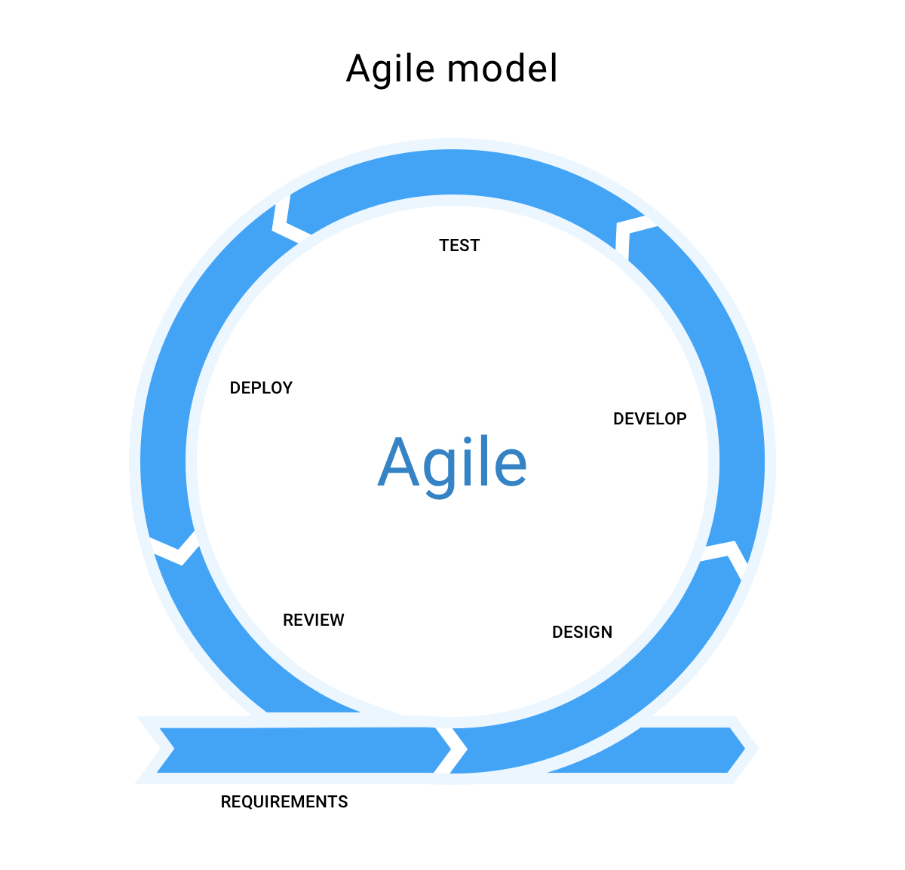

### 2.2 Quality Management

* Defect Prevention
* Reviewing
* Unit Testing
* Integration Testing
* System Testing

### 2.3 Training Plan

|  |  |  |  |
| --- | --- | --- | --- |
| **Training Area** | **Participants** | **When, Duration** | **Waiver Criteria** |
| Java Spring Boot | Ho Quang Bao |  | Mandatory |
| Flutter | Nguyen Duy Anh  Ho Quang Bao  Dang Manh Tuong |  | Mandatory |

## 3. Master Schedule

|  |  |  |  |  |
| --- | --- | --- | --- | --- |
| **#** | **Deliverable** | **Effort** | **Due Date** | **Deliverable Scope** |
| 1 | Project Plan |  |  |  |
| 2 | SRS |  |  |  |
| 3 | Design |  |  | Architecture Design,ERD, Database |
| 4 | Code Package |  |  | Code & Unit test, System test cases |
| 5 | UAT Package |  |  | Codes, System test reports |
| 6 | Final Package |  |  | Final Codes & documents, User manual |

## 4. Project Organization

### 4.1 Team & Structures

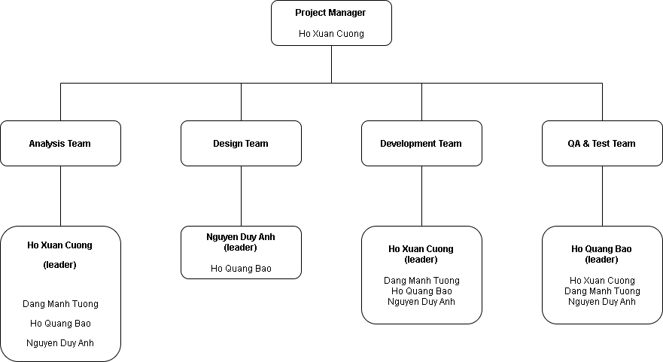

### 4.2 Roles & Responsibilities

|  |  |
| --- | --- |
| **Role** | **Responsibility** |
| Project Manager | Ho Xuan Cuong |
| Analysis Leader | Ho Xuan Cuong |
| Analysis Member | Nguyen Duy Anh, Ho Quang Bao, Dang Manh Tuong |
| Design Leader | Nguyen Duy Anh |
| Design Member | Ho Quang Bao |
| Development Leader | Ho Xuan Cuong |
| Development Team | Nguyen Duy Anh, Ho Quang Bao, Dang Manh Tuong |
| Test Leader | Ho Quang Bao |
| Test Member | Nguyen Duy Anh, Dang Manh Tuong |

## 5. Project Communication

### 5.1 Communication Plan

|  |  |  |  |  |
| --- | --- | --- | --- | --- |
| **Communication Item** | **Who/ Target** | **Purpose** | **When, Frequency** | **Type, Tool, Method(s)** |
|  |  |  |  |  |
|  |  |  |  |  |

### 5.2 External Interface

#### a. FU Contacts

|  |  |  |  |
| --- | --- | --- | --- |
| **Function** | **Contact Person**  **(name, position)** | **Contact address**  **(email, telephone)** | **Responsibility** |
| Supervisor | Nguyen Trung Kien | kiennt@gmail.com  0912656836 | - Provide document template - Give instruction to project team - Review deliverables - Supervise project status |
| Supporter | Nguyen Thi Mai Phuong | Phuongntm5@fe.edu.vn | - Provide document template  - Receive report project  - Answer questions about the project |

#### b. Customer Contacts

|  |  |  |  |
| --- | --- | --- | --- |
| **Function** | **Contact Person**  **(name, position)** | **Contact address**  **(email, telephone)** | **Responsibility** |
| Supervisor | Nguyen Trung Kien | kiennt@gmail.com  0912656836 | - Provide document template - Give instruction to project team - Review deliverables - Supervise project status |
| Supporter | Nguyen Thi Mai Phuong | Phuongntm5@fe.edu.vn | - Provide document template  - Receive report project  - Answer questions about the project |

## 6. Configuration Management

### 6.1 Tools & Infrastructures

|  |  |
| --- | --- |
| **Programming languages** | Java, ReactJS, Flutter |
| **Framework** | Java Spring Boot |
| **API** | API |
| **DBMS** | Microsoft SQL Server |
| **IDEs/Editors** | Spring tool suite |
| **UML tools** | Visio, Astah |
| **Version Control** | Git hub |
| **Deployment server** | Amazon Web Service |
| **Project management tool** | Microsoft Project |

### 6.2 Document Management

We use google drive to manage our document

### 6.3 Source Code Management

We use github to manage our code